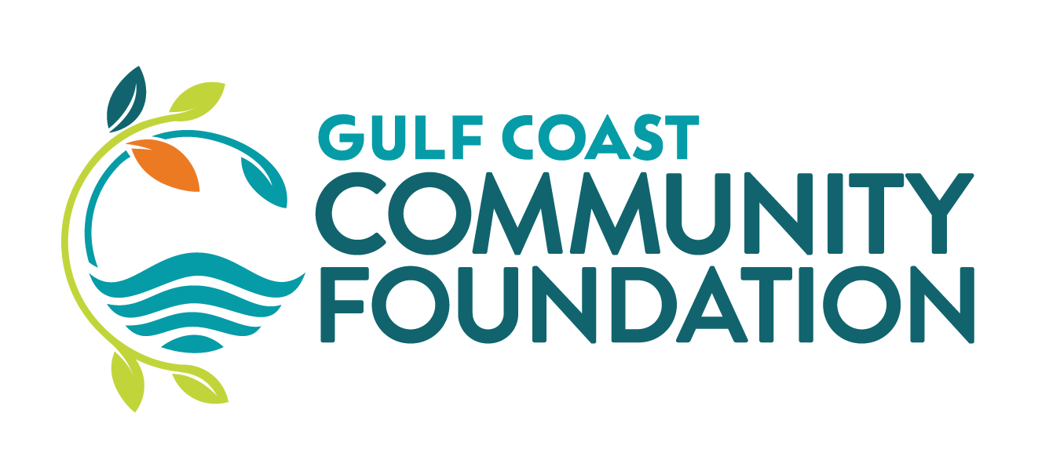

Kelly Education, a division of Kelly Services, Inc. Scholarship

Scholarship to be awarded to a student at Gulfport High School majoring in education. Scholarship recipient must have a demonstrated financial need, in addition to exhibiting leadership qualities, while maintaining a minimum of a 2.5 G.P.A. on a 4.0 scale

Scholarship award in the amount of $2,500 to be paid over one year at $1,250 per semester.

