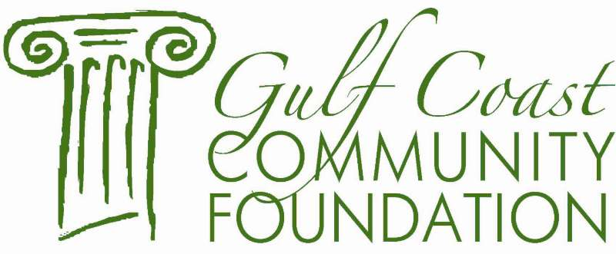

ROTARY CLUB OF BILOXI
SCHOLARSHIP CRITERIA

Academic Record 60%
Leadership & Community Service 30%
Financial Need 10%

This scholarship program is open to any graduating senior (Class of 2020) whose parent(s) or legal guardian(s) reside in the City of Biloxi, any home schooled senior student, registered with the County Attendance Office whose parent(s) or legal guardian(s) reside in Biloxi; any graduating senior whose parent is a member of the Rotary Club of Biloxi. Students must have earned a minimum C+ (2.5 grade point average or equivalent).

